**JF Morrison and his K&E 4138 Radio Engineers slide Rule.**

This article is a supplement containing more details on aspects of my paper on the Morrison Radio Engineer slide rule.

I’ll begin with the actual operation of the slide rule during calculations of ground wave field strength.

**The K&E 4138 propagation computation**

As described in the main article, the K&E 4138 propagation scales were intended to compute the electric field strength E of a broadcast transmitter at a specified distance and radiated from a vertical antenna. The basic equation for this was:

$\text{E}\text{ =}\frac{K∙\sqrt{P} ∙f\left(ρ\right)}{d}$ (equation 1)

Where:

***P*** = the power radiated from the antenna

***K*** = a constant determined by antenna height =6.170 for quarter wave vertical antenna

***E*** = the field strength at distance **d** from the antenna

***d*** = distance from the antenna

$f\left(ρ\right)$ = the attenuation factor at distance **d**, and

***r*** = the ‘numerical distance’ ***r***

The numerical distance ***r*** was given as:

***r =***   (equation 2)

Where:

***f*** = frequency of the transmitter

***r*** = distance from the antenna

$σ$ = conductivity of the soil

On the K&E 4138, a ground wave computation required two steps. First, the attenuation factor was computed, then the attenuation factor was used in the field strength computation.

**Example: find the field strength at 40 miles from a 30 KW transmitter over a surface having conductivity 3.5 e-14 EMU.**

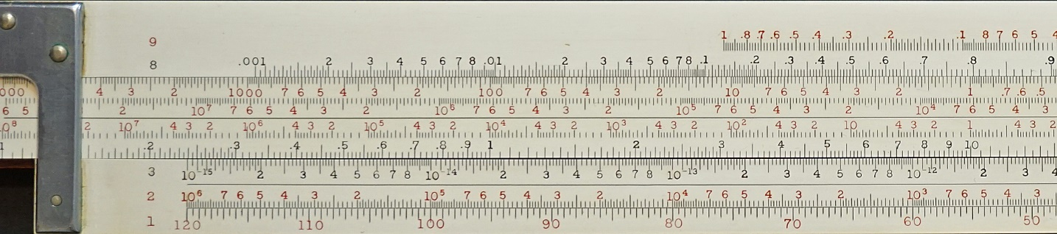

1. Set 1450 KHz on Frequency (scale 4) over 3.5 e-14 emu (s scale 3)
2. Read attenuation .0249 on ATTEN I (scale 8) at 40 miles (scale 7)

Note that attenuation can be read for any distance with this setting.

**Figure 1. Finding the Attenuation factor for 30 KW 1450 KHz transmitter, soil conductivity 3.5 e-14**

In ***figure 1***, by setting frequency ***f*** (scale 4) over **s** (scale 3) the value of the attenuation factor ***A*** is given (scale 8) for every distance ***d*** (scale 7, top of slide). The setting is the magnitude of the ***numerical distance*** scaled by a factor (ref equation 2).

In this example, the distance from the transmitter is 40 miles, which gives an attenuation factor of 0.0249.

An important feature of the scale design was that this same setting permitted the engineer to read off the attenuation factors for any distance, something which would have been needed for finding contours of constant field strength, as discussed next.

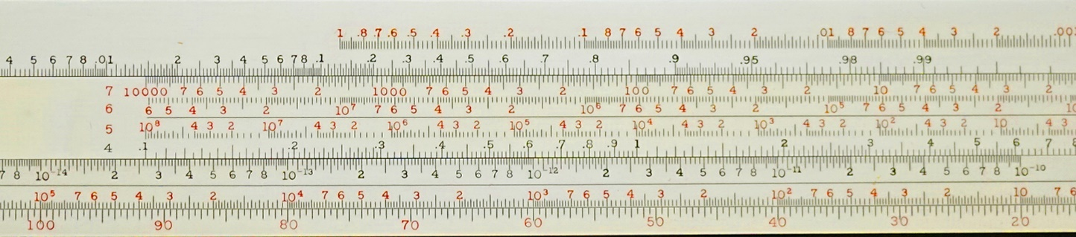

1. Set 40 miles (scale 7) under .0249 on ATTEN II
2. Under 30 KW (scale 5) find E = 120 mV/m (scale 3)

**Figure 2. Computing the field strength 40 miles from the transmitter, using the attenuation from Figure 7.**

In ***figure 2***, the 0.0249 value is transferred to the ***ATT. FACTOR II*** scale. The distance of 40 miles is placed under 0.0249 on scale 9. The field strength ***E*** is computed to be 120 mV/m for a transmitter power of 30 kW. This step computes the field given by equation 1.

Also, note that scale ***ATTEN FACTOR II*** (scale 9) is a multi-decade log scale shifted to multiply by a constant. The unit value of the ***ATTEN. FACTOR II*** scale is over ***6170*** on the E mV/m scale. This is the constant K in equation 1, representing a quarter wavelength tall antenna. As this constant varied based on the antenna height, a simple ratio conversion could be used to rescale the computation for different antennas.

**Field contour maps**

As Morrison wasn’t teaching his audience how to be radio engineers, his manual only hints at aspects of their work.

One of the basic design goals for broadcast radio engineers would be to predict the coverage area for the intended transmitter. This activity would be typically accomplished by computing contours of specific field strengths. For example, the boundary where field strength drops below “2 mV/m” might represent the end of strong reception, thus a contour of E= 2mV/m overlaid on a map would represent the area of primary service. A rule of thumb about field strength is that it needs to be at least 25 times higher than the ambient electrical noise if a signal is to be sufficiently clear. The background noise level is quite a bit higher in large urban areas than in the country or small towns.

For design purposes, the engineer would want to know the distances where good reception became intermittent reception, and where intermittent reception ceased. Regrettably, there is no formula that computes a distance from the transmitter given a desired *field strength*. Instead, computations find a field strength given a specified *distance*. For this reason, it would be necessary for the engineer to first plot curves of field strength vs distance within the service area, then use these curves to find the distance where the field strength dropped below specified boundaries.

In effect, the engineer would need to precompute the same kind of field strength curves that were published by the FCC in the ‘Standard of Good Engineering” (called the “FCC Standards” for the remainder of this article). As mentioned above, an appropriate setting on the K&E 4138 provides attenuation factors for all distances in range of the scale. A user of this slide rule could quickly compute and draw a field intensity vs distance curve and locate the significant distances for specific field strengths. The curve locates the distance or distances at which the transmitter’s field strength had specific thresholds to serve their target audience.

Figure 3 shows a modern AM broadcast station’s ground wave contours of 2.0 mV/m (local), 2.0, mV/m (distant) 0.5, and 0.15 mV/m (fringe). KYCN-AM transmitter operates at 250 Watts. This concept of having zones of service originated in the 1930s and was discussed in the FCC “Standards”.

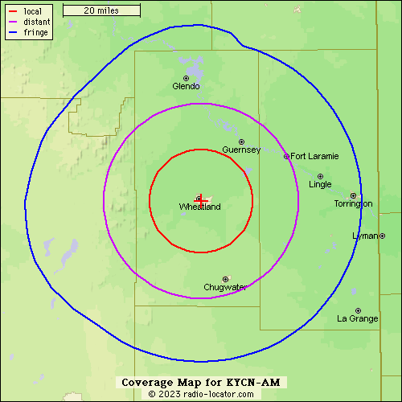

Figure 3 KYCN-AM broadcast contours

This small station shows a circular pattern, largely because the distances are small enough that differences in ground conductivities have had little effect. The little bump on the top of the blue curve arises from having a wet area near “Glendo”; this would have higher conductivity.

As an alternative to a contour of constant field strength, one might use a polar chart such as figure 4. This shows the magnitude of the field strength at a constant *distance*, caused by different soil conductivities.

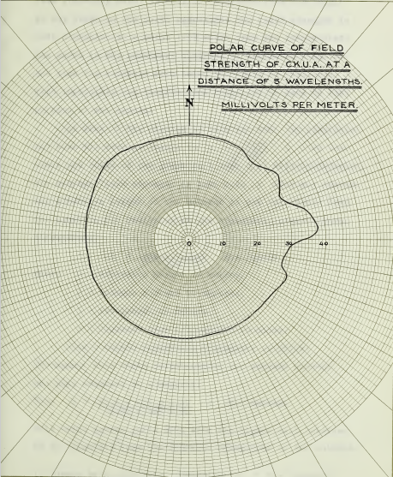

Figure 4 Polar map of field strength at 5 wavelengths CKUA

Commonly 8 to 16 points around the circle would be needed to create a smooth curve.

If the conductivity of the earth were uniform in all directions, then this would be a circle. The Ground conductivity assumptions might vary based on the topography near and distant from the transmitter. It appears that although comprehensive maps of ground conductivity were available, they were incomplete or not sufficiently precise. The evaluation and design of new stations would require measurements of ground conductivity.

Morrison’s manual for the K&E 4138 includes an early ground conductivity map, collected from data from stations across North America.

**The Federal Communications Commission “Standards of Good Engineering”**

In 1939, the FCC published its ‘Rules and Regulations’ alongside the ‘Standards of Good Engineering Concerning Standard Broadcast Stations’. These FCC documents established terms and concepts that continue to be used today.

For my article I argued that the set of ground wave curves provided with the FCC’s ‘Standards of Good Engineering Concerning Standard Broadcast Stations’ killed the market for the K&E 4138 because they were convenient and easy to use. I’ll add those “Standards” offered useful data beyond the ground wave curves. For example, it also included graphs and tables of information related to sky wave transmission. The “Standards” considered sky wave propagation as a ‘secondary’ part of the service area for classes I stations.

My own experience is that the curves are in fact simpler to work with than the slide rule, given they only require the computation of a scaling factor to account for the designed transmitter power.

**The pesky inaccuracy...**

While preparing my paper, I decided to plot propagation curves using data computed from my own K&E 4138. I discovered that the FCC ground wave curves had a different shape than curves generated from the K&E 4138 slide rule. This discovery concerned me as it raised another possible reason for the slide rule’s early demise.

The FCC curves show a steeper drop-off, starting between 100 and 200 miles, not present in the K&E 4138-generated curves. After some review of materials, it became clear that this difference owed to the fact that Norton’s computations accounted for the additional attenuation effects from a spherical earth, while the 4138 was designed for the well-known ‘Plane Earth’ approximation. I obtained the same characteristic curve using Everitt’s formulation as the K&E 4138.

In my attempts to reproduce curves for various conductivities, I observed that the plane earth model used in the K&E 4138 appears to give gives acceptable results out to about 200 miles. The general rule of thumb for AM broadcast range is about 100 miles in the daytime.

Figure 4 Ground wave curves compared to FCC data

In the end, I concluded that it was ***not*** “inaccuracy” that led to the demise of the K&E 4138.

First of all, Morrison mentions that it uses the “plane earth” model in his manual, and included a reference to the Norton paper that first described the improved ‘spherical earth model’. He would have been fully aware of the discrepancy and plainly considered the plane earth approximation fit for use.

That left unfortunate timing as the most plausible solution.

The “FCC Standards” first appeared in August 1939 and the earliest mention of the K&E 4138 was in a Bell journal dated June 1939. I believe this places the release of the K&E catalogue to be likely May 1939, certainly no earlier than April 1939.

By that reckoning, the slide rule was only out for three to four months before the FCC published their “Standards”. When the “FCC Standards” arrived, it packaged a variety of useful best practices and design aids (including the ground wave curves), with some mandatory requirements. This killed the market for the slide rule

**Sky Wave vs Ground Wave Propagation**

The K&E 4138 propagation face is designed specifically for ground wave propagation. As mentioned in the JOS article, ‘ground waves’ follow the curvature of the earth and have a magnitude dependent primarily on the distance from the transmitter. For ground waves, signal strength does not depend on the time of day and would be constant at any given location.

Sky waves are absorbed by the ionosphere during the day, and do not contribute to reception. At night, the ionosphere can reflect some energy back to the earth.

The K&E 4138 and the accompanying manual do not offer any guidance for computations involving sky-wave reception. This may signify that by the time this slide rule was developed, sky wave propagation had ceased being considered a ‘normal’ mode of propagation, that is, a part of the expected range of a station, and more of a sometimes-unwanted side-effect.

The common layout for antennas in the 1920s was a horizontal or an inverted-L antenna (a raised horizontal antenna with a vertical component between the antenna and the transmitter). This layout was convenient as it could be erected on the top of buildings. However, it also meant that less of the radiation pattern contributed to ground wave propagation. An outcome would have been that more of the audience would be served by ‘intermittent’ sky-wave refraction and less of the audience would be served by ground-waves.

When the 1930s commenced, more stations adopted a quarter wave vertical antenna, a practice which appears to have become dominant by the middle of the decade. Vertical antennas are superior to horizontal for ground wave propagation. However, vertical broadcast antennas were more expensive to construct, as they require a very tall mast. For example, at the middle of the AM band, a quarter wavelength 1 MHz broadcast antenna would be 75 meters (250 feet) tall. The lowest AM frequency antenna would be almost twice as high.

The switch to vertical antennas was likely a byproduct of the rapid growth in the number of broadcasting stations. Stations needed to provide reliable service to wider audiences than ever before.

As mentioned in the main JOS article, sky waves are absorbed by the ionosphere during the day but refracted down to earth after the sun sets. Because the sky waves refract from different points in the ionosphere, they return to earth at various distances, although the maximum range is dictated by the radius of the earth and the height of the refracting layer from the surface of the earth (about 110 km). The distance between points A and B in figure 5 is about 1200 miles.

Figure 5 the maximum distance for sky wave transmission.

Given that sky waves could be received with varying intensities over the course of the evening, at distances as great as 1200 miles, early broadcasters would have had access to a wide rural audience. However, reception would be subject to issues like fading, and short periods of availability; it simply was not as reliable as ground wave propagation, as the latter provided consistent reception 24 hours a day.

Also, sky waves can interfere both with the originating station and distant stations. If a sky wave landed relatively close to the transmitter, the inbound wave might interfere with the original ground wave signal. At distances beyond the area served by the originating station, sky waves could interfere with other stations, if the signal strength is large enough.

By the time that the vertical antenna started to become popular in the United States, the use of directional antennas started to also be common. Whether sky wave interference was a major contributor to the shift is not entirely clear (to the author), but certainly, the transition corresponded to a higher reliance on ground wave propagation. Of note, the 1939 FCC “Standards” devoted considerable attention to sky wave reception, with the intention of identifying when it constitutes interference as opposed to an intentional secondary service.

I’ll also add that since WWII, two additional measures have commonly been taken to combat interference: First, most high-power stations cut their power in half in the evening, to reduce sky wave field strength. Second, some stations use special directional antennas only at night to retain a significant ground wave signal in a preferred direction.

**Further reading**

After I finished my JOS article, I came across a Master’s thesis from 1935 about measuring the field intensity of a Canadian broadcast station: [Field Strength Survey of CKUA](https://archive.org/details/williams1935), by David G. Williams.

I include it here because the author included a fine summary of the state of the art of the mathematics of groundwave attenuation and included a more complete reference list than I’d been able to collect in months of looking for information. Also, big kudos to the author for his clear understanding of the materials. I trust he obtained his degree.

The [world radio history](https://www.worldradiohistory.com/index.htm) website is a marvelous resource of books, magazines, journals, and ephemera related to the history of radio (and some television).

Of particular interest for my research were the pages on the [Institute of Radio Engineers](https://www.worldradiohistory.com/IRE_Proceedings.htm) and the [Federal Communications Commission](https://www.worldradiohistory.com/FCC-Publications-Guide.htm)

William Everitt’s book, “***Communications Engineering***”, mentioned in Morrison’s manual as a reference, has the clearest explanation of the math behind this slide rule I’ve been able to find. Archive.org has a copy [here](https://archive.org/details/communicationeng00ever/page/n7/mode/2up), the relevant chapter is XIX, and it was new to the second edition 1937.

Beyond the theory about the vertical antenna, it also has comparisons between the theory and actual recent measurements. I happen to think that this book may have helped Morrison, either by inspiring him to develop his slide rule, or simply giving him confidence as to its calculations.